# Meeting Summary: Final Tasks and Questions About Specification

**Date:** 26/02/24

**Participants:**

* Member 1 (Dylan Carter - 720007761 - [dc713@exeter.ac.uk](mailto:dc713@exeter.ac.uk))
* Member 2 (Jamie Elder - 720011935 - [je497@exeter.ac.uk](mailto:je497@exeter.ac.uk))
* Member 3 (Victor Smith - 720087895 - [vphs201@exeter.ac.uk](mailto:vphs201@exeter.ac.uk))
* Member 4 (Daniel Hart - 700046191 - [dh590@exeter.ac.uk](mailto:dh590@exeter.ac.uk))
* Member 5 (Ziyad Alrubian - 710057514 - [zaa203@exeter.ac.uk](mailto:zaa203@exeter.ac.uk))
* Module Lead (Solomon Oyelere – [s.oyelere@exeter.ac.uk](mailto:s.oyelere@exeter.ac.uk))

**Session Lasted:** 1 hour 45 minutes.

## Objective:

This meeting we set out to finalise our code and make sure everything was functional and add anything we may have missed, discuss our final product for sprint 1 with the module lead and go through our submission, also anything else we may have missed on the Continuous Assessment specification that we would need to complete before the deadline.

## Discussion Points:

### Finalising Code and Final Tasks:

We started the meeting by going over what we had done previously and what we had left to do. We realised that we needed to bootstrap the Django models as well as actualising the admin page, also we needed to apply the scores for the meal events and fix some bugs. With these tasks left to do the bootstrapping was assigned to Dylan and Daniel, the admin page was assigned to Victor and Ziyad, applying the scores and fixing bugs as well as aiding people who needed it was tasked to Jamie. We were all comfortable with the roles we were given after this and happy with where our app was heading.

### Specification Details and Questions:

With the module lead we went through the specification and were told that our project needed 3 folders as a part of the submission. technical-documents containing all the sourcecode that we had been creating and everything that was included in the making of the application. A process-decuments folder containing all the meeting write ups and consistent kanban screenshots pertaining to our progress on the application as a whole and a product-documents folder. This would hold a Product Design document describing our back-end and formatting it in a way that would be useful for clients or users and a UI document showcasing our front-end decisions and again formatting in a way that would be useful for clients or users. Daniel had already been keeping a track of the Kanban and so only the product-documents needed doing. These documents were split, Jamie to do the UI document as he was most familiar with the layout of all the pages and how the app worked as a whole and Victor to do the Product design document as he made all the designs for how the how should work.

### Final Product and Submission

As our product was what was originally stated in the first meeting with the module lead, he was happy with what our submission would be. A simple app that allows you to login, play ‘Foodle’, join a group via a QR code and create a group cook from a variety of recipes. With this we began discussion about our submission for this sprint. We talked about who was going to submit the final .zip file and what we needed to do to upload the peer review.

## Conclusion:

The meeting ended with us happy with the app we created and all of us given some simple tasks to complete in order for us to match the criteria given to us fully. The main bulk of the app was completed and now it was time for documentation and submitting our work properly as well.

## Next Steps:

1. Creating and submitting the final project for the first sprint.

## Action Items:

1. Bootstrapping the Django models.
2. Finalising the admin page.
3. Bug fixing.
4. Applying scores to planned meals.
5. UI Document.
6. Product Design Document.

# Meeting Related Images

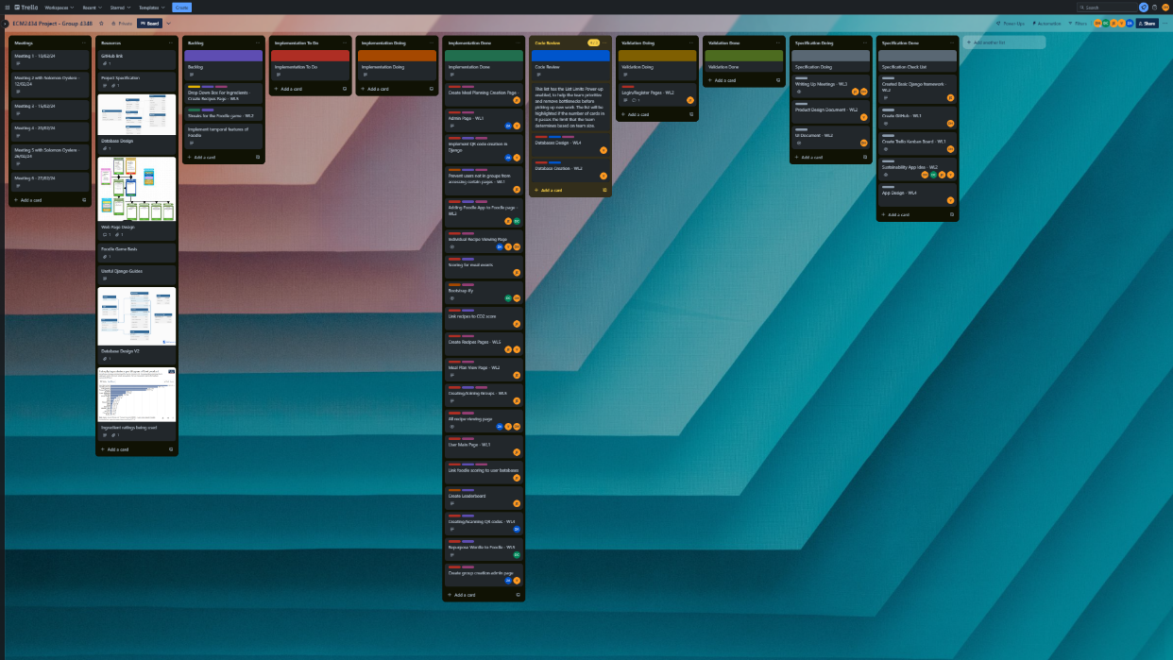

Above example of Kanban screenshots